SCITS

Sticky notifiation:

We have made ‘location’ and ‘risk’ related notification clikable. User can click on the title of notifications.

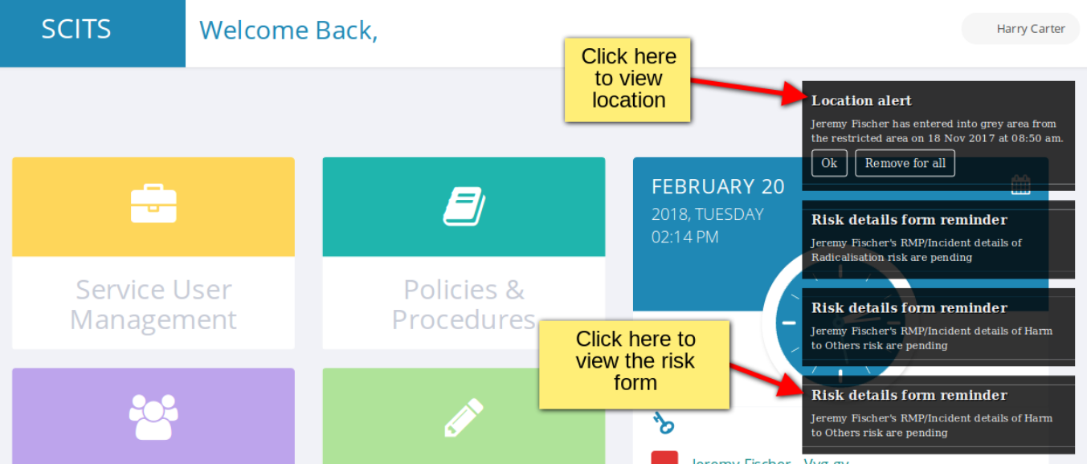

When a user will click on risk detail reminder notification title then corresponsding service user’s profile page will be open and relative risk detail form will be open as shown below.

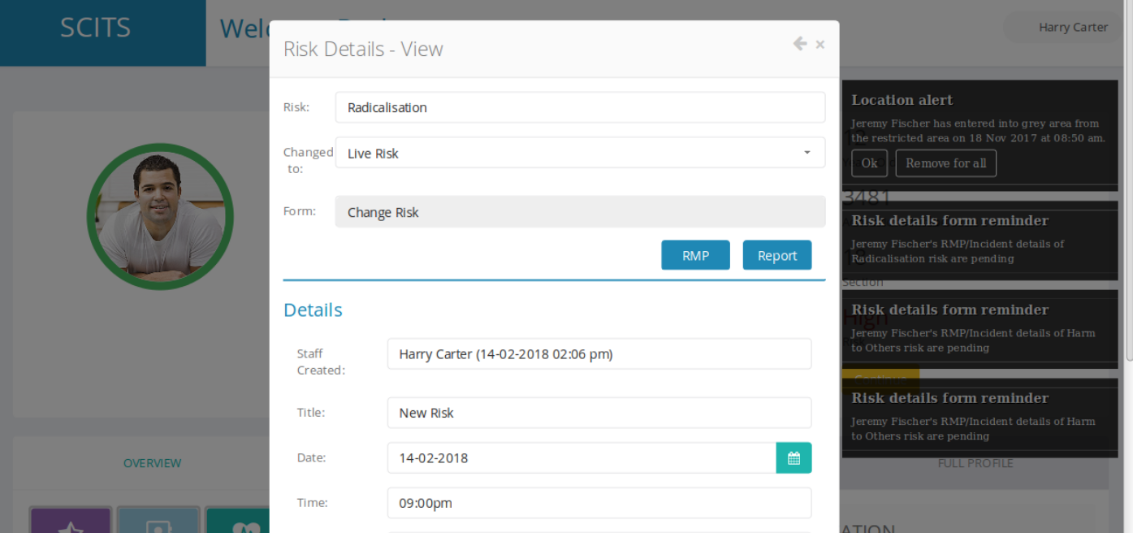

We have also shown continue button in the service user profile page.

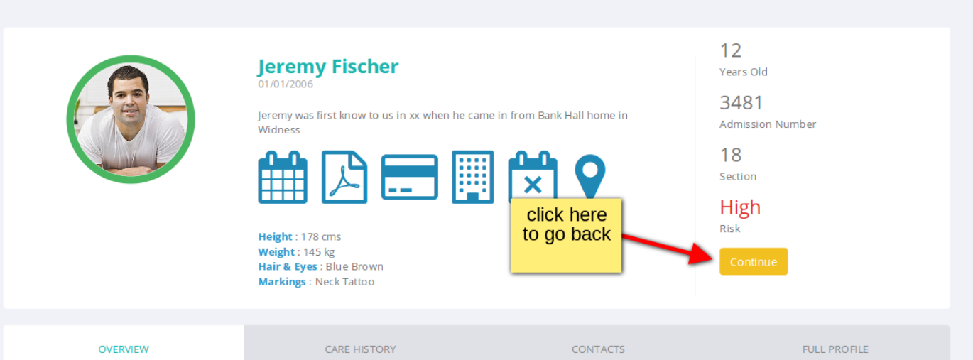

Same when location alert is clicked then service user location history page will be shown as given below.

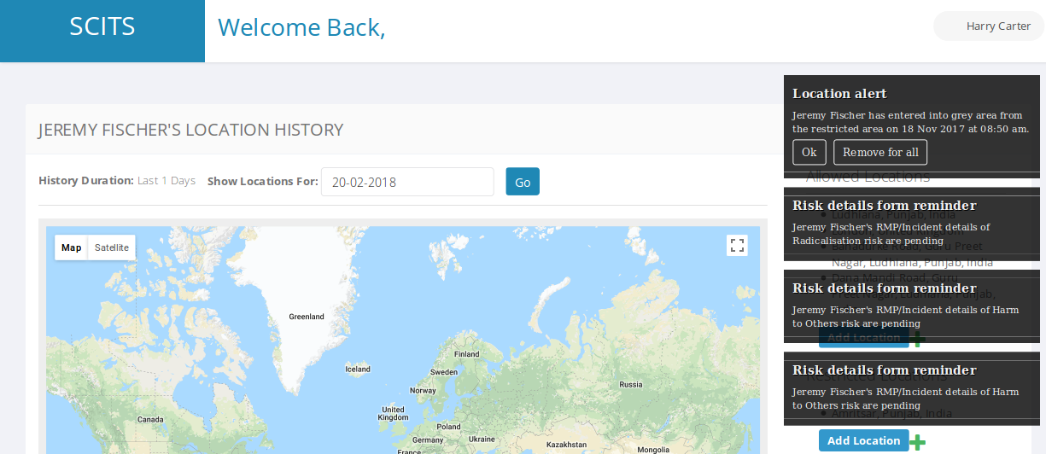

Till now we have made only two types of notifications dynamic,
“location alert” & “Risk detail form reminder”. If you want same functionality for other type of notifications too then please let us know.

Thanks

